Wicklow County Council – Formal Complaint Form
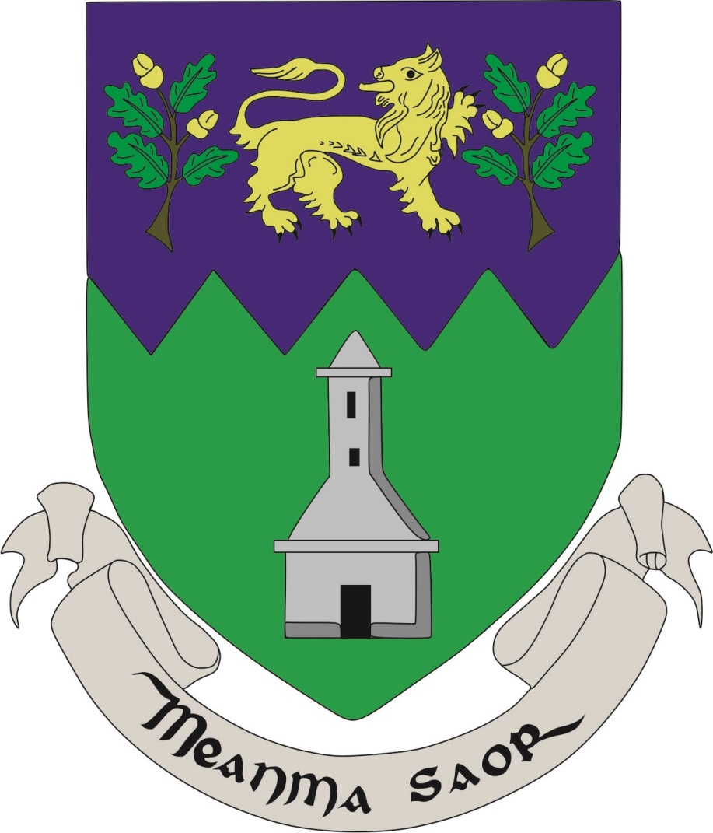

We aim to provide an efficient, effective service in a courteous manner to all our Customers. If you are not satisfied with the quality of service you receive, you can let us know.
If you are dissatisfied with the quality of service you received, please return this form to:
- Customer Service Manager, Wicklow County Council, County Buildings, Wicklow Town, Co. Wicklow A67 FW96
or
- E-mail to customerservice@wicklowcoco.ie

Your complaint will be dealt with in accordance with the complaints and appeals procedure adopted by Wicklow County Council.
Name: ________________________________________________________
Address: ________________________________________________________
Phone No: ________________________________________________________
Email: ________________________________________________________
Date: ___________________________

Please specify which department or service your complaint relates to:
________________________________________________________________________
Please provide details of your Complaint:
_______________________________________________________________________
_______________________________________________________________________
_______________________________________________________________________
_______________________________________________________________________
_______________________________________________________________________
_______________________________________________________________________
_______________________________________________________________________

